**WALTER SISULU UNIVERSITY**

**HUMAN COMPUTER INTERACTIONS PRPJECT**

**GROUP MEMBERS : NIKO MNDENDE - 221638377**

**: SIYA THENO - 220459251**

**: LUTHO NAKO - 220631476**

**: ONGEZWA QEGWANA - 220161445**

**: MASIXOLE SIKWEZA - 221532692**

**: YAMUKELA MADELA - 220484066**

**: SOLATHISO DUMAKADE - 220391947**

**: AYEZA QUMBA - 219482454**

**Pharmacy Care**

Pharmacy Care is an application designed to assist in the three relationships of a Patient, Doctor and a Pharmacy. This application allows a doctor to consult a patient virtually and give them a prescription which is paid for via internet banking then delivered to the patient’s preferred address e.g. The doctor will consult a patient virtually using the app then give them the prescribed medication list which will be automatically sent to a Pharmacy then the pharmacy will select the prescribed medication then send/deliver it to the patient’s physical address.

The aim/purpose of this application is to help reduce the spread of Corona Virus. It is known that the more an individual goes out in public, he/she is exposed to Covid 19 and stand at higher risk of not only being affected, but also being a carrier making him/her a danger to the ones around them.

Pharmacy Care does not only protect you from the spread of the Corona Virus, it makes taking care of your health much easier as everything is automatically done for you, the only thing you have to do is just log in and choose a doctor suitable for your condition. This also exposes patients to different medical doctors who specialize in many things, meaning that one does not have to travel afar and pay for transport just see maybe a Paediatricians Doctor that doesn’t live locally or around your located area.

The Benefits of using application is that you do not have to go to the pharmacy and you will not be faced with waiting in line at the pharmacy or at the doctor’s and leaving your home. Studies show that buying drugs on the internet also saves money as it offers better pricing and the patient’s privacy, and confidentiality is safe. There is an increase access to medication that is normally unavailable in offline stores, lower transaction, product costs, convenience and greater anonymity for consumers.

**HOME PAGE**

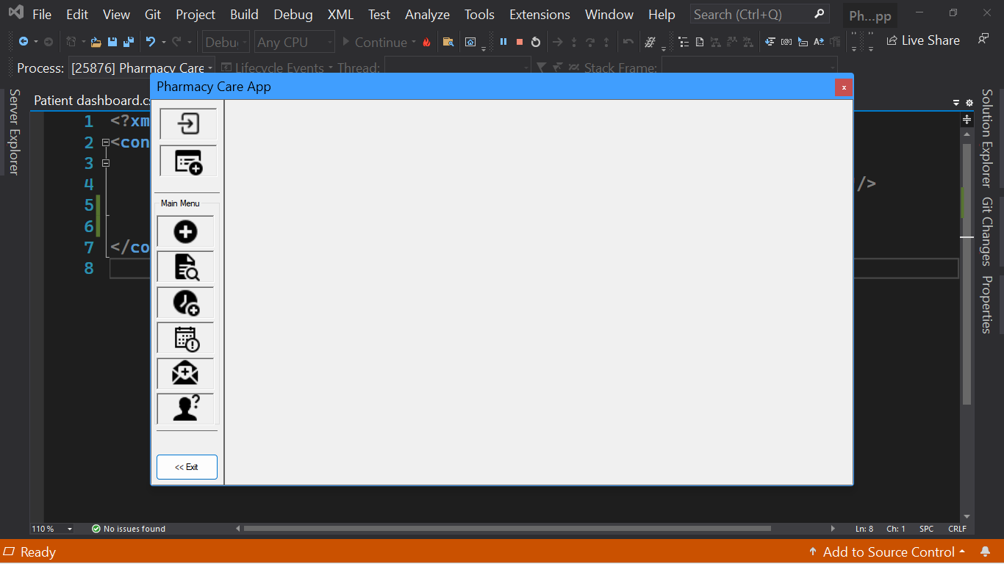

This is the home page whereby the User selects which action they want to use on the application. On this page we have ‘Log In’, ‘Create New Appointment’, ‘View Appointment’, Modify Appointment’, ‘View Prescription’, ‘Remove Prescription’ and ‘Update’

**LOGIN_USER**

This the “Login User” page where the user logs in using username and password. If the user does not have an account, they have an option to sign up or create a new account.

If the user types in the wrong/incorrect details error code” 401 “will appear on the screen.

**PATIENT DASHBOARD**

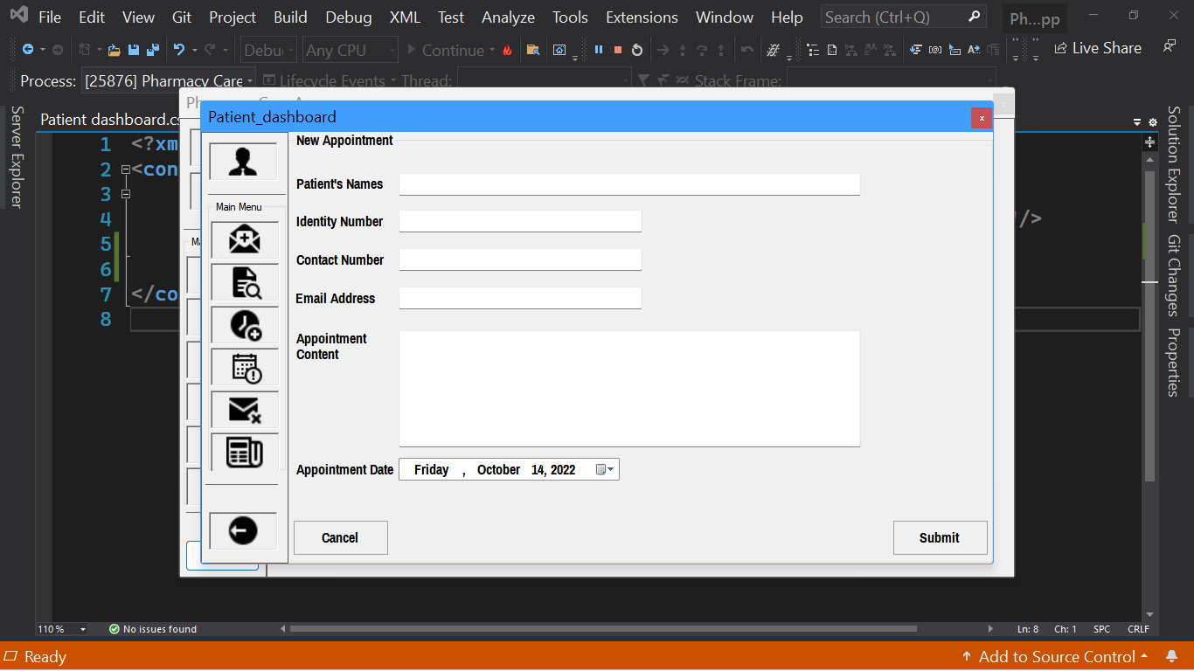

On The Patient Dashboard the user is able to set their appointment, but first they need to insert their details such as their name, Identity Number, Contact Number and Email Address.

**Prescription Page**

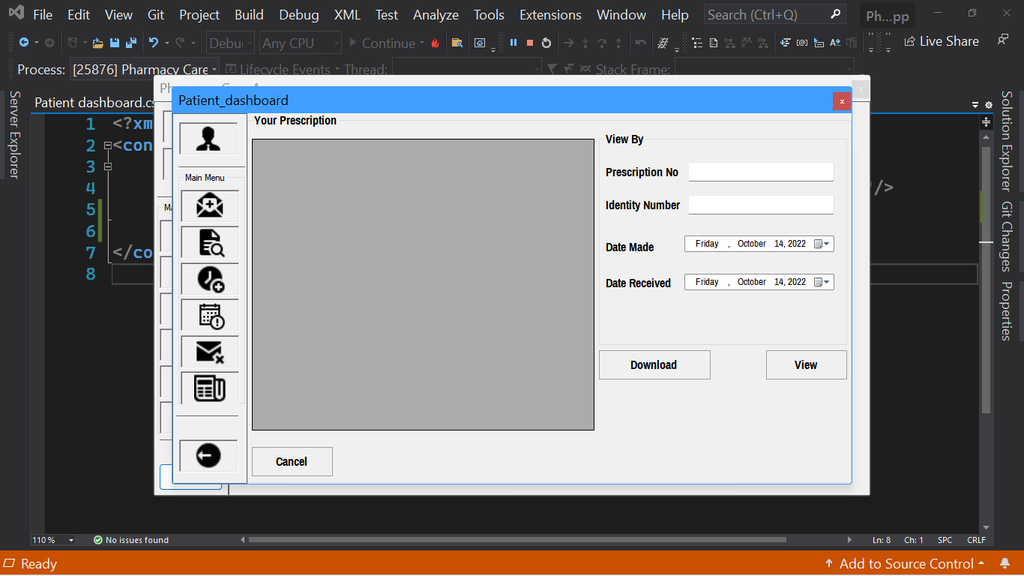

On the Prescription The patient can confirm and download their prescription. As soon as the patient receive the prescription, they need to validate it. Confirm the patient’s name and personal information to be certain that they have matched the prescription to the correct patient

The pharmacist has developed an individualized Patient-cantered care plan in collaboration with other health care professionals and the patient or caregiver that is evidence-based and cost effective. This process includes establishing a care plan that: addresses medication-related problems and optimizes medication therapy.

**Doctor’s Dashboard**

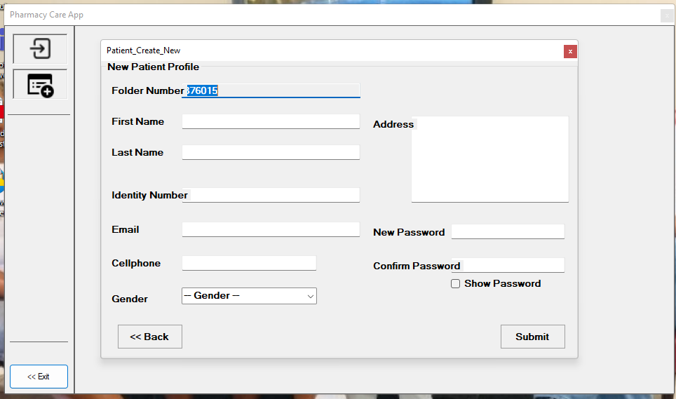

On this page we have the Doctor’s Dashboard whereby the doctor/doctors can create their profile or start a new account. On this profile, they must add their first name, last name ID number, email address and cell phone number then they can create a password to be able to access their profile.

If the user happens to have forgotten their password, they are required to confirm their cell phone number or email address so that an OTP (One Time Pin) can be sent in order for them to be able to set another password that they will not forget.